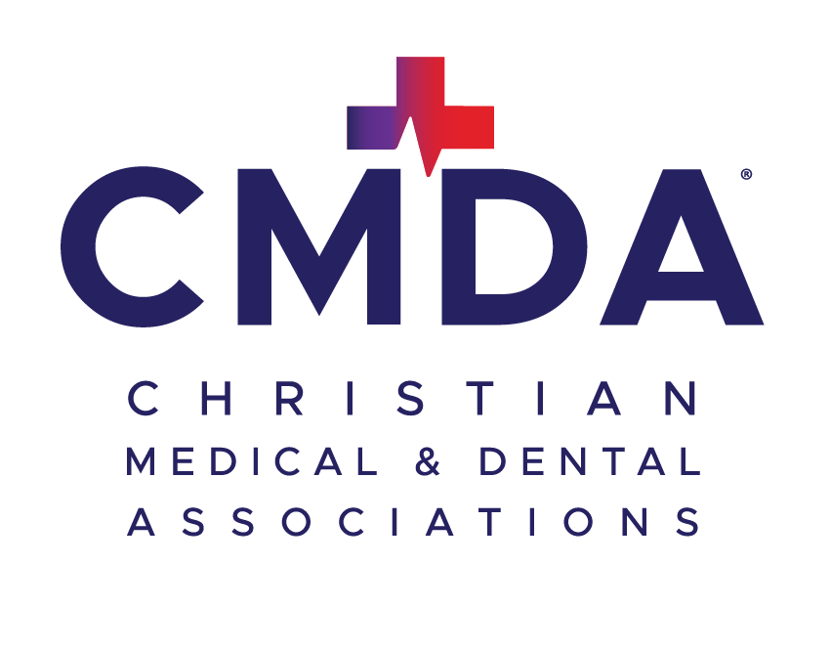
IU and Marian STUDENT MISSION SCHOLARSHIP application
(Please print and, if necessary, use the back or additional page for your answers)

- Personal Information:
  - Name: ___________________________________________________________________________
  - Address / State / Zip: _________________________________________________________________________________
  - Cell: (_____) ____________________ Email: (non-school please) ___________________________
  - Program: Med: ____ Den: ____ Year: (circle) 1 2 3 4
  - Date of Birth: ____________ Male: ____ Female: ____
  - Married Students: (Spouse’s Name) __________________ (Children’s Names) __________________
  - Church Affiliation: ______________________________________
- CMDA Participation:
  - CMDA Activities: (Please list) _____________________________________________________________________
  - National CMDA Member: ____Yes ____No
- Personal Affirmation How does one becomes a Christian? Have you taken that step? Explain on separate page.
- Experience:
  - Previous experience abroad: ____Yes ____No
  - If yes, briefly describe place(s) & purpose: _______________________________________________
  - What motivated your interest in medical missions? What are your goals for this trip? ______________________________________________________________________________________________________________________________________________________________________________________________________________________________________________________
- Preparation:
  - Passport: ____Yes ____No Trip Registration: ____Completed ____Pending
  - Fund Raising Begun? ____Yes ____No
  - If yes, list sources you have contacted for support: ________________________________________________________
  - Percentage Funded: ____90% ____75% ____50% ____25% or less
  - Support Still Needed: $________
- Conditions:
  - Scholarship recipients must be members of national CMDA. Funds must be used for an Indiana University CMDA mission trip. Within 30 days of trip completion, please submit a written report to CMDA Indianapolis (summary of activities and value to the student) including photographs if possible). If funding has been provided by other sources, please withdraw your application and return any scholarship funds. Should I receive a scholarship, I agree to abide by the conditions listed and accept full responsibility for my actions. I further release CMDA from any claims of whatever nature arising from any act of any person, corporation, or entity not under the direct supervision and control of CMDA.
Please return to: info@centralindianacmda.org

